Name _____________________________ ______________Block Review for Chapter 2 test
Terms &people to know: (include examples when possible)
- Vestigial Structures
- Homologous
- Adaptation
- Plate tectonics
- Paleontologist
- Inferences
- Strata
- Charles Darwin
- Lamarck
- Hominids
- Who is Lucy? When was she found? _____________
- Evolution
- Geologic time- what came first? (time line)
- What is stratigraphy? How is it used?
- How old is the earth? ___________________
- What does the fossil record tells us?
- Artificial selection
- Natural Selection and what leads to it?
- Cladograms- know how to read them & make inference’s
- Diversity
- Why don’t all organisms turn into fossils?
Evolution Review Worksheet Name: Date:
Answer all questions using COMPELTE SENTENCES.

1. What is evolution?

2. What are 3 examples of adaptations?
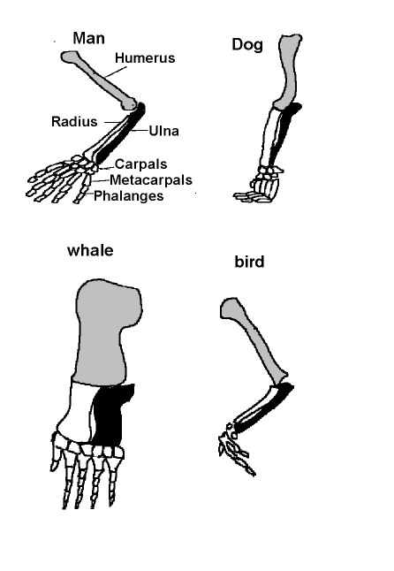

3. What are the 3 main lines of evidence for evolution? Describe each one using a COMPLETE SENTENCE.

4. What does the picture on the right show?

5. What did Charles Darwin observe on the Galapagos Islands?

6, Charles Darwin studied finches on the Galápagos Islands. The finches on each island had slightly different shaped beaks. According to Darwin, how did the finches all get different beaks?

7. What is natural selection? (the definition)

8. Draw a picture to show what happens in each step of natural selection.

Step | Picture
1. Populations over-reproduce
2. Individuals in a population vary
3. Favorable adaptations are selected
4. Favorable adaptations accumulate

9. Light-colored lizards move to an area where there is dark-colored sand. After many years, most of the lizards are dark- colored. Why do you think this happened?

Name Date Period

Evolution Review- Chapter 2
Directions: Answer the following questions using your notes and textbook. .

1. What is the term for a feature that allows an organism to survive better in its environment?

2. All the individuals of a species that live in a particular area are called a

3. The remnant of an organ that had a function in an early ancestor is known as a(n)
_______________________________Structure
4. What observations did Charles Darwin make about finches in the Galápagos Islands?

5. The hind leg bones shown in the whale in Figure 10.2 are examples of
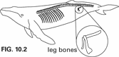
6. What is the process in which humans breed organisms for certain traits?

7. Individuals that are well adapted to their environment will survive and produce offspring

8. If two species have similar DNA sequences, it would indicate that they
9. Coevolution is a process in which species

10. Two species that are closely related become increasingly different through
11. A river has cut a deep canyon that has separated a population of rodents into two groups. This separation is an example of what type of isolation?
12. The separation of populations by barriers such as rivers, mountains, or bodies of water is called

13. Most fossils form in rock
mushrooms
Insects
humans
Trees
Bacteria
14. On the cladogram above, are humans more closely related to mushrooms or trees? How do you know?

