Name ___________________ Block ___________
Date ___________________ Group _________
Brain Anatomy
Go to this website: http://outreach.mcb.harvard.edu/animations/brainanatomy.swf
Follow Spike the Neuron on a tour through the human brain.
On the diagram of the brain below identify the four lobes of the cerebrum and the sensory cortex and motor cortex.
- Write the name of each part on the outside of the brain and draw a line to the correct area.
- Color each lobe a different color. Color the sensory and motor cortexes a darker shade of the color of the lobe in which they are found.
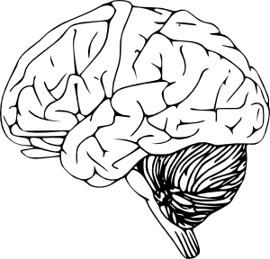
Fill in the chart below with the correct information for each part.
Brain Part | Function(s)
Frontal Lobe
Parietal Lobe
Temporal Lobe
Occipital Lobe
Sensory Cortex
Motor Cortex

