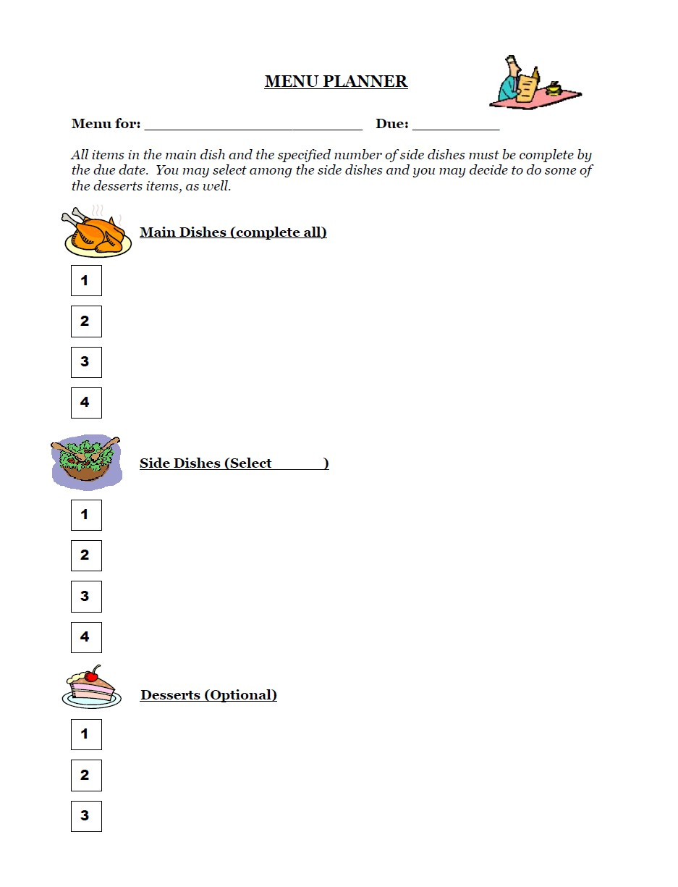

Gizmo on Cell Division. Do the 5 questions on the computer

Microscope Station

3
Gizmo: Cell Division

Station: Microscope activity

Mitosis Video

Grab Bag Activity

Create a “Flip Book”

Use Clay to model the different stages of Mitosis. Have Mr.
Mitosis Video Grab Bag Activity Making a flip Book
Marotta or Mrs. Woods check your model.

Word Sort Station

Rate of Mitosis mini lab

Create a powerpoint on 5 types of
Asexual reproduction

